AR Book Find
You can visit www.arbookfind.com to look up book
summaries, levels, and the number of points each book is worth.

AR Home Connect
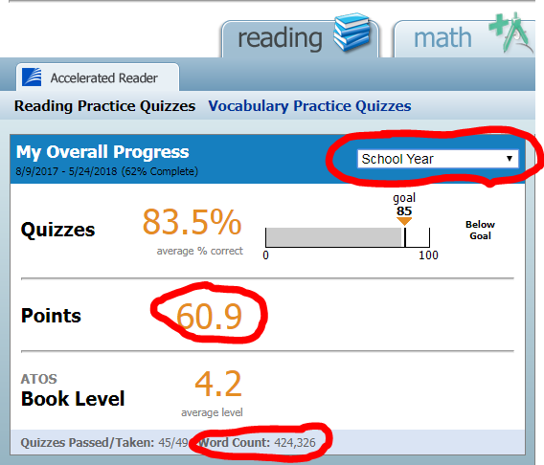
Go to: http://hosted127.renlearn.com/210581/homeconnect/
Username: your child’s student ID#
Password: your child’s first and last initial
Click on "email setup" to be emailed ​each time your child takes an AR test!​
Select "School Year' to see how many words your child has read and how many points your child has
earned for the year.

AR Testing
AR testing can be done daily in all ELA classes and in the library at recess/during library visits. Please speak with the ELA teacher or Mrs. Silk for more information on your child’s requirements.

Accelerated Reader Test Log
Name: ________________________ SEMESTER: 1st OR 2nd AR Deadline: ___________________
ZPD (Suggested ONLY): ________________ Pts. Goal This Semester: ______________
Title of Book | Quiz Number | % Earned on test | Points Earned | Total Points
1.
2.
3.
4.
5.
6.
7.
8.
9.
10.
11.
12.
13.
14.
15.
16.
17.
18.
19.
20.

Accelerated Reader Test Log
Name: ________________________ SEMESTER: 1st OR 2nd AR Deadline: ___________________
ZPD (Suggested ONLY): ________________ Pts. Goal This Semester: ______________
Title of Book | Quiz Number | % Earned on test | Points Earned | Total Points
1.
2.
3.
4.
5.
6.
7.
8.
9.
10.
11.
12.
13.
14.
15.
16.
17.
18.
19.
20.

Accelerated Reader Test Log
Name: ________________________ SEMESTER: 1st OR 2nd AR Deadline: ___________________
ZPD (Suggested ONLY): ________________ Pts. Goal This Semester: ______________
Title of Book | Quiz Number | % Earned on test | Points Earned | Total Points
1.
2.
3.
4.
5.
6.
7.
8.
9.
10.
11.
12.
13.
14.
15.
16.
17.
18.
19.
20.

40 BOOK CHALLENGE

The challenge, if you choose to accept it, is to read 40 books this year. BUT, you must read a certain number of books in each genre. Example: 4 realistic fiction, 2 poetry, etc. As long as you pass the test, you can have your teacher initial your log. You have until the last AR deadline! Once completed you will get your picture taken for the website/social media page. You will also have a champion poster of you hung in the library and receive an award on awards day.

Book Genres for 40 Book Challenge

- Poetry--Verse and rhythmic writing with imagery that creates emotional responses.
- Mystery--Fiction dealing with the solution of a crime or the unraveling of secrets.
- Biography/Autobiography/Memoir--Narrative about a person’s life; a true story about a real person.
- Historical Fiction--Story with fictional characters and events in a historical setting.
- Science Fiction--Story based on impact of actual, imagined, or potential science, usually set in the future or on other planets.
- Fantasy--Fiction with strange or other worldly settings or characters; fiction which invites suspension of reality.
- Nonfiction--Literature dealing with an actual, real-life subject.
- Realistic Fiction--Story that can actually happen and is true to life.
- Action/Adventure--An adventure that takes the characters on a personal journey or to different geographical locations
- Traditional Literature (any of the following):
  - Fable--Narration demonstrating a useful truth, especially in which animals speak as humans; legendary, supernatural tale.
  - Folklore--The songs, stories, myths, and proverbs of a people or "folk" as handed down by word of mouth.
  - Mythology--Legend or traditional narrative, often based in part on historical events, that reveals human behavior and natural phenomena by its symbolism; often pertaining to the actions of the gods.
  - Legend--Story, sometimes of a national or folk hero, which has a basis in fact but also includes imaginative material.
- Graphic Novels—technically a format, and not a genre. These books are in a comic-book style with graphics and illustrations. Graphic novels can be made of ANY genre.

40 Book Challenge Log
Directions: After you read and test on a book, have your teacher check your AR score and initial next to the title. Books over 300 pages count as 2 books! You must pass the test for it to count.

Genre: Poetry (2 Books)
Title | AR Percentage | Initials
Genre: Mystery (2 Books)
Title | AR Percentage | Initials
Genre: Biography/Autobiography (2 Books)
Title | AR Percentage | Initials
Genre: Historical Fiction (2 Books)
Title | AR Percentage | Initials
Genre: Science Fiction (3 Books)
Title | AR Percentage | Initials
Genre: Fantasy (3 Books)
Title | AR Percentage | Initials
Genre: Action/Adventure (2 Books)
Title | AR Percentage | Initials

Genre: Graphic Novel (2 Books)
Title | AR Percentage | Initials
Genre: Nonfiction (4 Books)
Title | AR Percentage | Initials
Genre: Realistic Fiction (5 Books)
Title | AR Percentage | Initials
Genre: Traditional Literature (3 Books)
Title | AR Percentage | Initials
Genre: Your Choice (10 Books)
Title | AR Percentage | Initials

